**Event Delegation in React**

React registers event handlers at the root DOM container (e.g., the root div in a React app). This is an implementation of event delegation, where events are handled at a central place.

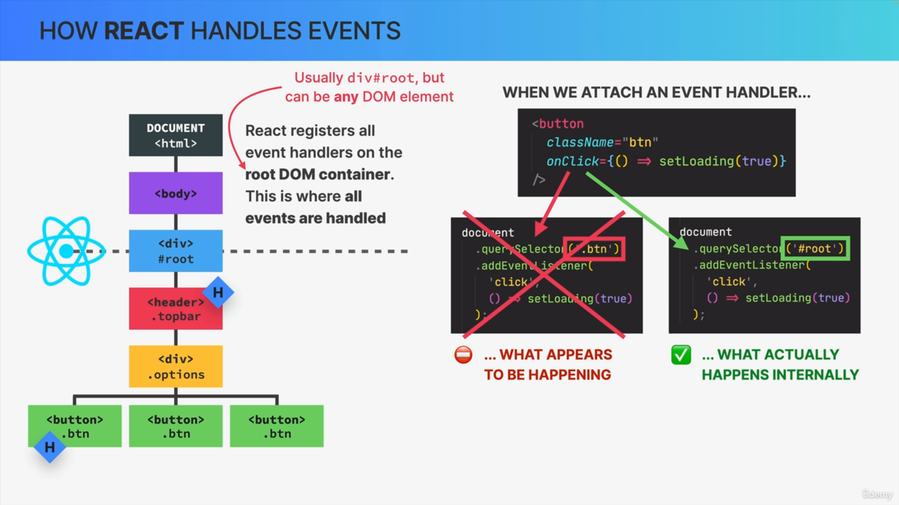

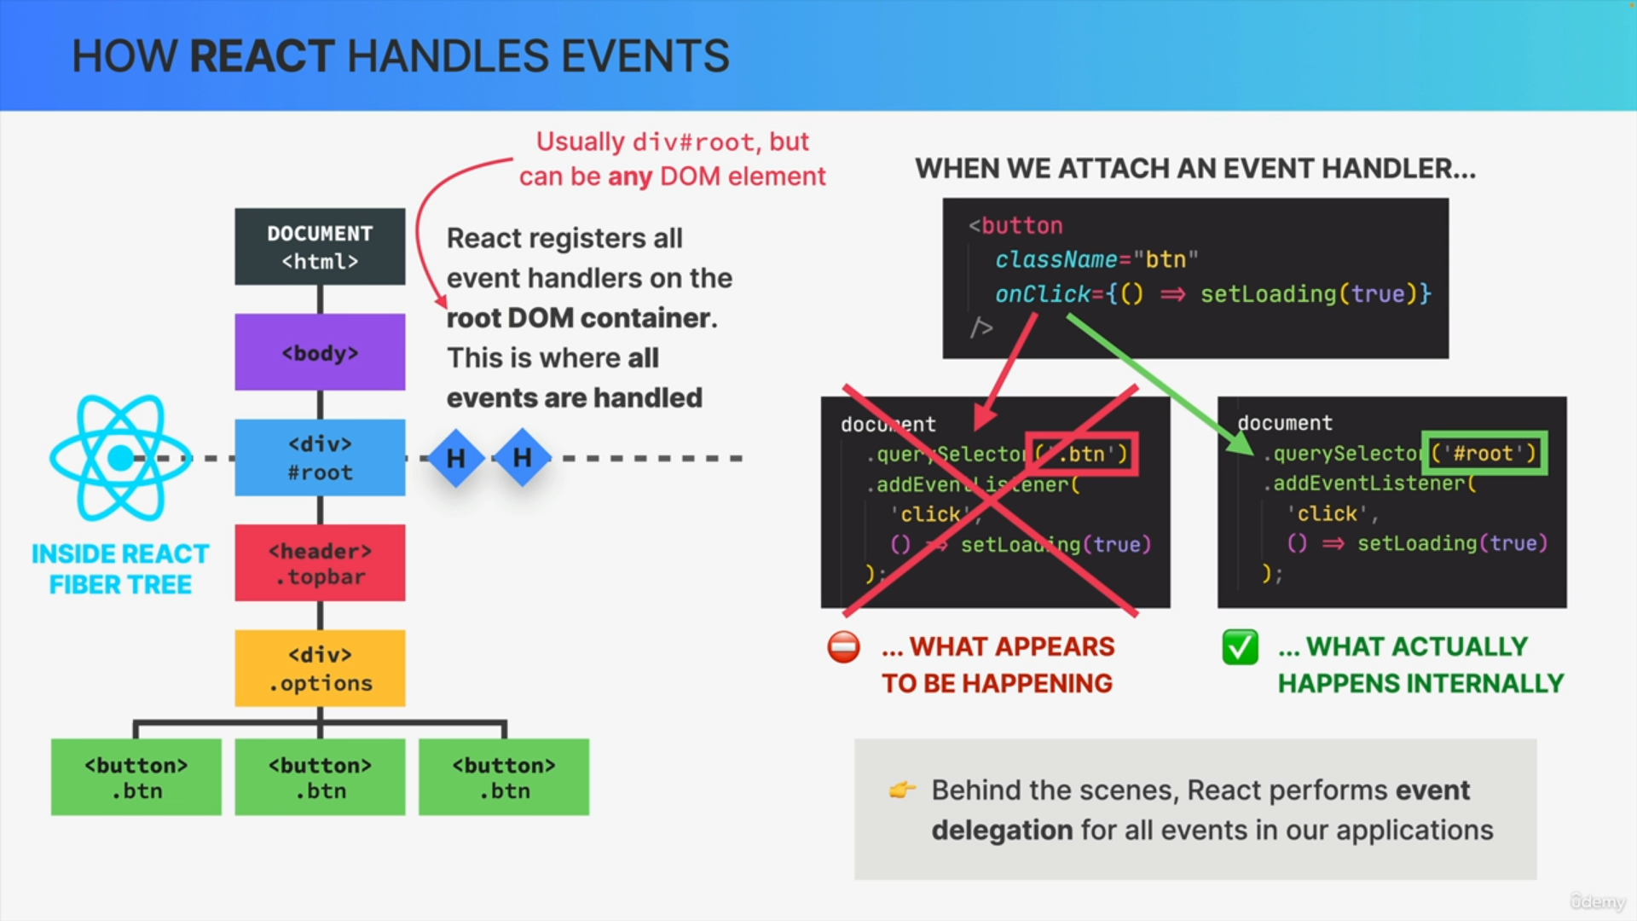

**Event Handling Phases in React**

* The event is created at the root and travels down the DOM tree.
* After reaching the target element, it bubbles back up.
* React handles the event at the root container based on the registered handlers.

**Synthetic Events**

React uses synthetic events, which are wrappers around native events, providing a consistent interface across different browsers. Synthetic events support important methods like stopPropagation and preventDefault.

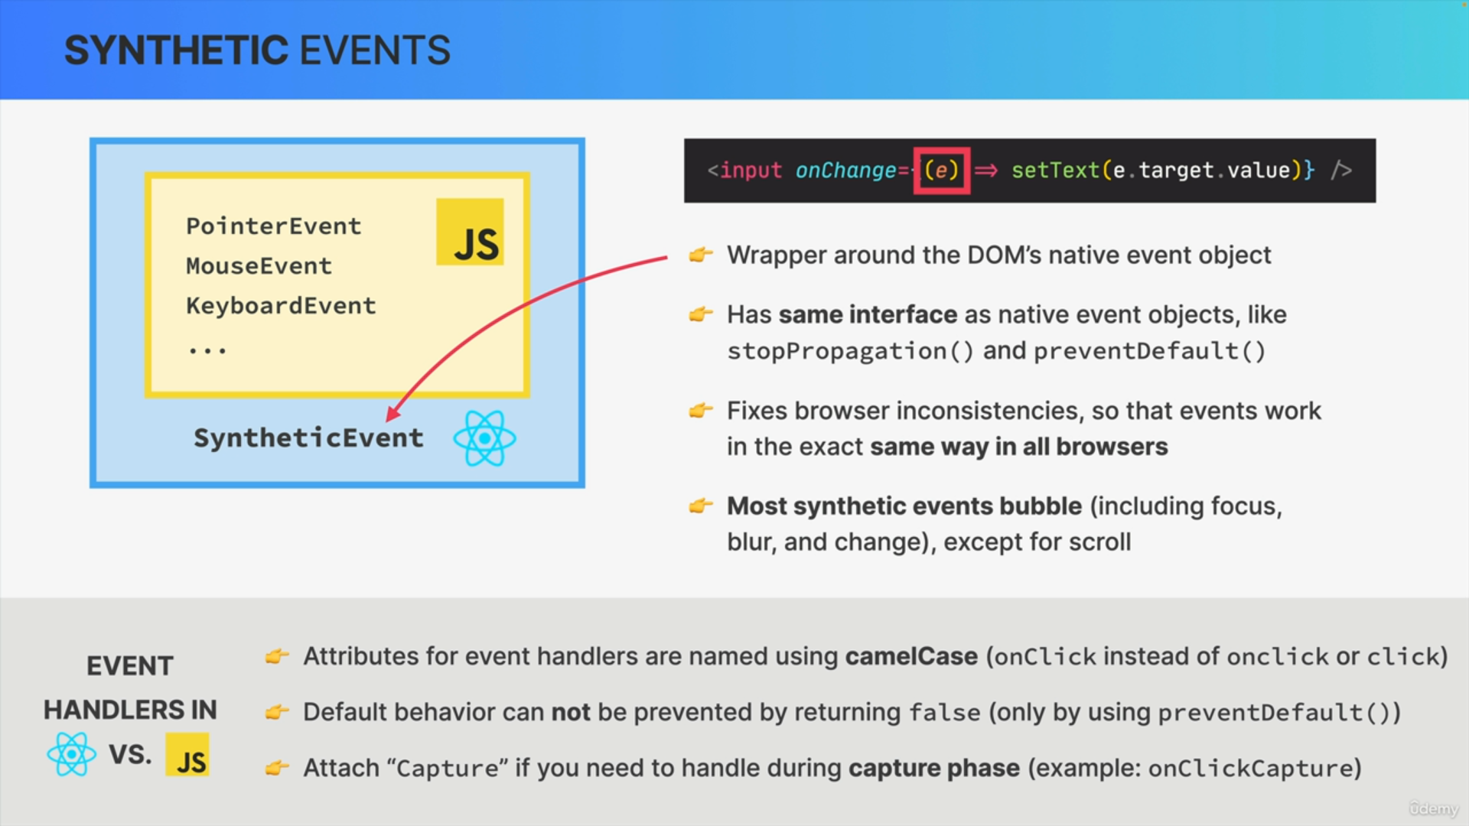

**Event Handler Differences in React vs. Vanilla JavaScript**

* **Naming Convention**

React uses camelCase (e.g., onClick) while HTML uses lowercase (e.g., onclick).

* **Preventing Default Behavior**

Use preventDefault in React, as returning false in an event handler won't work.

* **Capturing Phase Handling**

Attach Capture to event handler names (e.g., onClickCapture) to handle events in the capturing phase.